DEVICE 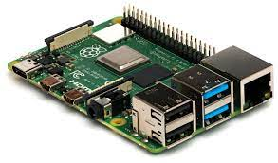

PHYSICS

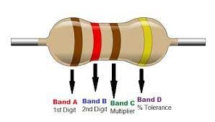 PROJECT

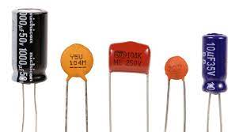 BY NAVEEN TIWARI

STUDENT ID: 522364

*CHARGING AND DISCHARGING OF A CAPACITOR IN A RC CIRCUIT*

**INTRODUCTIOn:**

This report is based on the circuit implemented in Simulink and Raspberry Pi. The objective is to get a detailed report on charging and discharging of a capacitor in a RC circuit. Especially the physical aspect, like how the charging and discharging is happening and the physics behind it. The report uses various formulas and law based on theoretical view and graphs and results based on experimental data.

**Capacitor:**

* Capacitors are devices that can store electric charge and energy.
* It is a passive electronic component with two terminals.
* Most capacitors contain at least two electric conductors often in the form of metallic plates or surfaces separated by a dielectric medium.
* The nonconducting dielectric acts to increase the capacitor's charge capacity. Materials commonly used as dielectrics include glass, plastic film etc.
* When the conductors of a capacitor are connected to a charging device (for example, a battery), charge is transferred from one conductor to the other until the difference in potential between the conductors due to their equal but opposite charge becomes equal to the potential difference between the terminals of the charging device.
* Where potential difference is the is the amount of [work](https://www.thoughtco.com/definition-of-work-in-chemistry-605954) energy required to move an electric charge from one point to another. The unit of potential difference is the volt. Or simply current times resistance
* The amount of charge stored on either conductor is directly proportional to the voltage, and the constant of proportionality is known as the capacitance This is written algebraically as

*Q* = *C*Δ*V*

.

The charge Q is measured in units of coulomb (C), the voltage

Δ*V*  in volts (V), and the capacitance C in units of farads (F). Capacitors are physical devices; capacitance is a property of devices.

Capacitors have several uses, such as :

.

* Capacitors pass AC current, but not DC current, so they are used to block the DC component of a signal so that the AC component can be measured.
* It can be used as filters in DC power supplies.
* Energy storage banks for pulsed lasers.
* A capacitor can be slowly charged to the necessary voltage and then discharged quickly to provide the energy needed. It is even possible to charge several capacitors to a certain voltage and then discharge them in such a way as to get more voltage (but not more energy) out of the system than was put in.This experiment features an *RC* circuit, which is one of the simplest circuits that uses a capacitor.

Resistor:

A resistor is a passive two-terminal electrical component that implements electrical resistance as a circuit element. In electronic circuits, resistors are used to reduce current flow, adjust signal levels, to divide voltages, bias active elements, and terminate transmission lines, among other uses.

It is measured in ohm’s and The behaviour of an ideal resistor is described by Ohm’s law which states that: under ideal conditions voltage Vacross a resistor is proportional to the current Ipassing through it, where the constant of proportionality is the resistance.

V = IR

V=I⋅R.

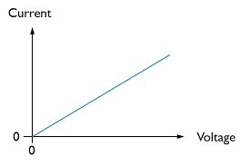

CHARGING AND DISCHARGING: 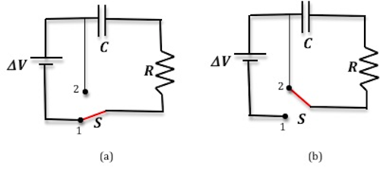

Charging:

Kirchhoff's loop equation states that the sum of all the electric potential differences around a loop is zero. It is also sometimes called Kirchhoff’s voltage law or Kirchhoff’s second law.

ΣΔ*V*=0

For the circuit shown in above Kirchhoff's loop equation can be written as:

Δ*V* –  Q/C - R*(dQ/dt)=0

Which after solving becomes:

Q = *Qf {* 1 − *e*(−*t*/*RC*) }

|  |
| --- |
|  |

where  *Qf*  represents the *final* charge on the capacitor that accumulates after an infinite length of time, *R* is the circuit resistance, and *C* is the capacitance of the capacitor. From this expression we can see that charge builds up exponentially during the charging process.

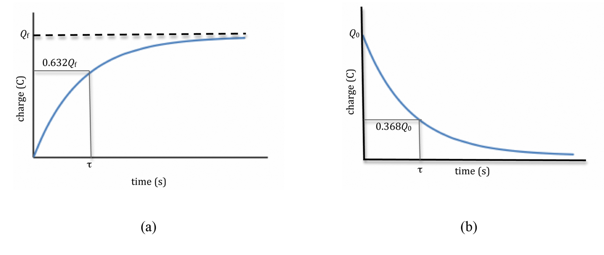

The above figure shows the charge versus time graph.

Discharging:

For the circuit shown in above Kirchhoff's loop equation can be written as:

Q/C - R*(dQ/dt)=0

Which after solving becomes:

Q = *Q*0 *e*(−*t*/*RC*)

where *Q*0 represents the initial charge on the capacitor at the beginning of the discharge, i.e., at

*t* = 0.

 we can see from this expression that the charge decays exponentially when the capacitor discharges, and that it takes an infinite amount of time to fully discharge.

Physical overview of charging and discharging:

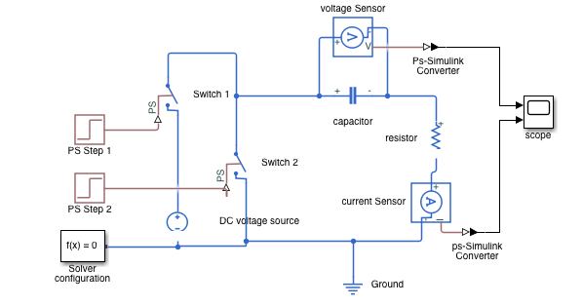

The figure above shows a RC circuit designed in Simulink.

Blocks used:

* 20 Volts DC voltage source.
* 10-ohm resistor.
* 40-mF capacitor.
* Ground, scope, voltage and current sensor.
* Ps step with step time of 5 seconds, two switches.

Working Principle:

In the beginning the capacitor is fully “discharged” and the switch 1 is fully open. Then t = 0, i = 0 and q = 0. When the switch is closed the time begins at t = 0 and current begins to flow into the capacitor via the resistor.

Since the initial voltage across the capacitor is zero, ( Vc = 0 ) at t = 0 the capacitor appears to be a short circuit to the external circuit and the maximum current flows through the circuit restricted only by the resistor R.

The current now flowing around the circuit is called the **Charging Current**and is found by using Ohms law as: i = Vs/R.

The capacitor (C), charges up at a rate shown by the graph below. The rise in the RC charging curve is much steeper at the beginning because the charging rate is fastest at the start of charge but soon tapers off exponentially as the capacitor takes on additional charge at a slower rate.

As the capacitor charges up, the potential difference across its plates begins to increase with the actual time taken for the charge on the capacitor to reach 63% of its maximum possible fully charged voltage, in our curve 0.63Vs, being known as one full Time Constant, ( T ).

This 0.63Vs voltage point is given the abbreviation of 1T, (one time constant).

For the sake of simplicity, I have used Ps step with step time of 5 second so after 5 seconds switch 1 is open automatically and switch 2 is closed. Now the DC voltage source is disconnected, and the circuit is grounded.

The stored energy built up during the charging process would stay indefinitely on its plates, (assuming an ideal capacitor and ignoring any internal losses), keeping the voltage stored across its connecting terminals at a constant value.

If the battery was replaced by a short circuit, when the switch is closed the capacitor would discharge itself back through the resistor, R as we now have a **RC discharging circuit**. As the capacitor discharges its current through the series resistor the stored energy inside the capacitor is extracted with the voltage Vc across the capacitor decaying to zero as shown below.

Now the time constant ( τ ) is still equal to the value of 63%. Then for a RC discharging circuit that is initially fully charged, the voltage across the capacitor after one time constant, 1T, has dropped by 63% of its initial value which is 1 – 0.63 = 0.37 or 37% of its final value.

Thus the time constant of the circuit is given as the time taken for the capacitor to discharge down to within 63% of its fully charged value. So one time constant for an RC discharge circuit is given as the voltage across the plates representing 37% of its final value, with its final value being zero volts (fully discharged), and in our curve this is given as 0.37Vs.

As the capacitor discharges, it does not lose its charge at a constant rate. At the start of the discharging process, the initial conditions of the circuit are: t = 0, i = 0 and q = Q. The voltage across the capacitors plates is equal to the supply voltage and VC = VS. As the voltage at t = 0 across the capacitors plates is at its highest value, maximum discharge current therefore flows around the RC circuit

When the switch is first closed, the capacitor starts to discharge as shown. The rate of decay of the RC discharging curve is steeper at the beginning because the discharging rate is fastest at the start, but then tapers off exponentially as the capacitor looses charge at a slower rate. As the discharge continues, VC reduces resulting in less discharging current.

Behavior of current during the process:

 In charging a capacitor, when the switch 1 is closed, current immediately begins to flow through the circuit. Electrons will flow out from the negative terminal of the battery, through the resistor R, and accumulate on the upper plate of the capacitor. And electrons will flow into the positive terminal of the battery, leaving a positivecharge on the plate of the capacitor

As shown in the graph below that as charge accumulates on the capacitor, the potential difference across itincreases (V = Q/C), and the current is reduced until eventually the voltage across the capacitor equals the emf of the battery. In discharging a capacitor, there is no battery involved, the capacitor is already charged and it is thenallowed to discharge through resistor.

### Time Constant (τ)

The product *RC* (having units of time) has a special significance; it is called the time constant of the circuit. The time constant is the amount of time required for the charge on a charging capacitor to rise to 63% of its final value. In other words, when

*t* = *RC*,

Q = *Qf {* 1 − *e*(−*1)*}

And

1 − *e*−1 = 0.632.

Another way to describe the time constant is to say that it is the number of seconds required for the charge on a discharging capacitor to fall to 36.8%

(*e*−1 = 0.368)

 of its initial value.We can use the definition (*I* = *dQ*/*dt*)  of current through the resistor and charging and discharging equation to get an expression for the current during the charging and discharging processes. 

charging:  *I* = +*I*0*e*−*t*/*RC*

discharging:  *I* = −*I*0*e*−*t*/*RC*

where I0 = Δ*V*0/R s the maximum current in the circuit at time t = 0.

Then the potential difference across the resistor will be given by the following.

charging:  Δ*V* = + Δ*V*f*e*−*t*/*RC*

discharging:  Δ*V* = − Δ*V*0*e*−*t*/*RC*

Note that during the discharging process the current will flow through the resistor in the opposite direction. Hence I and Δ*V*  in the above equation are negative. This voltage as a function of time is shown

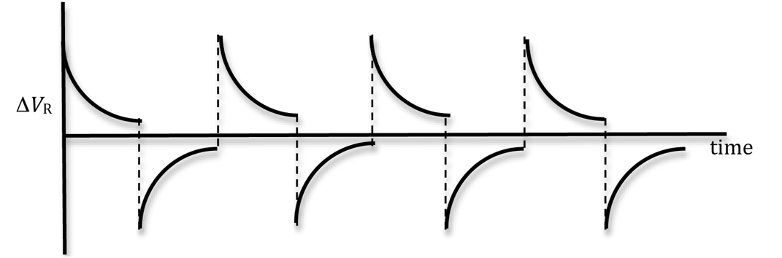

It is useful to describe charging and discharging in terms of the potential difference between the conductors (i.e., "the voltage across the capacitor"), since the voltage across a capacitor can be measured directly in the lab. By using the relationship

*Q* = *C* Δ*V*

Q = *Qf {* 1 − *e*(−*1)*}

Q = *Q*0 *e*(−*t*/*RC*)

which describe the charging and discharging of a capacitor can be rewritten in terms of the voltage. Merely divide both equations by *C*, and the relationships become the following.

charging:  Δ*V* = Δ*V*f { 1 − *e*(−*t*/*RC}*

|  |
| --- |
|  |

discharging:  Δ*V* = Δ*V*0*e*(−*t*/*RC*)

he graph of the voltage across the capacitor versus time is shown below.

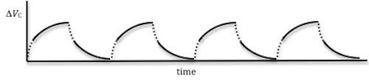

By rearranging the equation Δ*V* = Δ*V*f { 1 − *e*(−*t*/*RC} we get*

|  |
| --- |
| Δ*V*f − Δ*V* |
| Δ*V*f |

=. *e*(−*t*/*RC*).

Take the natural log (ln) of both sides of this expression and multiply by –1 to obtain

-ln (ΔVf - ΔV/ΔVf) = t/RC

A plot of  −ln((Δ*V*f − Δ*V*)/Δ*V*f)  versus time will produce a straight line graph with a slope of 1/RC. Similarly, for the discharging process,   this equation could be also written asΔ*V* = Δ*V*0*e*(−*t*/*RC*)

|  |
| --- |
| Δ*V* |
| Δ*V*0 |

= *e*(−*t*/*RC*).

Take the natural log (ln) of both sides of this expression and multiply by –1 to obtain

-ln ( ΔV/ΔV0) = t/RC

|  |
| --- |
|  |

Raspberry Pi:

**Raspberry Pi** is a series of small single board computers (SBCs) developed in the UK by the Raspberry pi foundation in association with Broadcom. The Raspberry Pi project originally leaned towards the promotion of teaching basic computer science in schools and in developing countries The original model became more popular than anticipated, selling outside its target market for uses such as robotics It is widely used in many areas, such as for weather monitoring because of its low cost, modularity, and open design. It is typically used by computer and electronic hobbyists, due to its adoption of the HDMI and USB standards.

Objective:

For Raspberry Pi I have used the charging and discharging data that we acquired during the lessons using Python To perform the fitting using MATLAB. I have used the R-square method to get the charging and discharging plot with least errors. I am also going to compare the goodness of the fit, the values of the Tau.

To build this circuit you will need:

* A breadboard
* A Raspberry Pi with GPIO header
* 1 PCF8591 analog-to-digital converter
* 1 resistor: any value between 330 Ohm to 10 k Ohm will be fine. For this example I use 10 k Ohm.
* 1 capacitor: any value between 100 uF and 470uF will be fine.
* set of male to female and male to male wires .

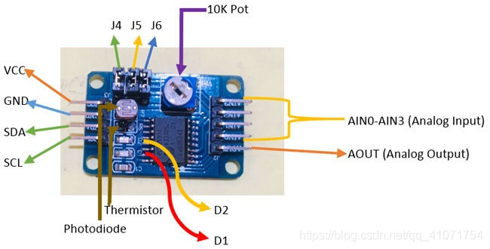PCF8591 is an 8 bit analog to digital or 8 bit digital to analog converter module meaning each pin can read analog values up to 256. It also has LDR and thermistor circuit provided on the board. This module has four analog input and one analog output. It works on I2C communication, so there are SCL and SDA pins for serial clock and serial data address. It requires 2.5-6V supply voltage and have low stand-by current. We can also manipulate the input voltage by adjusting the knob of potentiometer on the module. There are also three jumpers on the board. J4 is connected to select the thermistor access circuit, J5 is connected to select the LDR/photo resistor access circuit and J6 is connected to select the adjustable voltage access circuit. There are two LEDs on board D1 and D2- D1 shows the output voltage intensity and D2 shows the intensity of supply voltage. Higher the output or supply voltage, higher the intensity of LED D1 or D2. You can also test these LEDs by using a potentiometer on VCC or on AOUT pin.

Here’s the schematics to connect the circuit to Raspberry Pi:

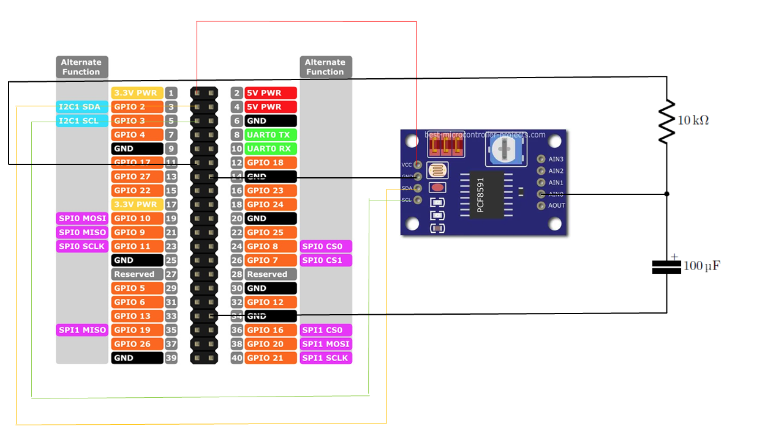

1. Remove the Jumpers (used to acquire data from the mounted sensors) from the PCF8591
2. Connect VCC pin of the PCF8591 to pin1 (3.3V) of the Raspberry GPIO
3. Connect GND pin of the PCF8591 to whatever GND pin of the Raspberry GPIO
4. Connect SDA pin of the PCF8591 to the SDA pin (GPIO 2) of the Raspberry GPIO
5. Connect SCL pin of the PCF8591 to the SCL pin (GPIO 3) of the Raspberry GPIO
6. Connect a female to male wire from GPIO17 to one slot of the breadboard
7. Insert a resistor in another slot of the same (connected) line up to a free slot on another line
8. Connect the positive pole of the capacitor in another slot of the same (connected) line (ending of the resistor) up to a free slot on another line
9. Connect the negative pole of the capacitor to another GND pin of the Raspberry
10. Connect a female to male wire from the AIN0 of the PCF8591 to the positive connected line of the capacitor (acquiring the voltage to the capacitor poles)
11. Power on your Raspberry and open the Python environment
12. Now here are the steps to build the circuit:
13. Connect one wire between one GND (ground) pin of the Raspberry Pi and the blue line of the breadboard.
14. Take the LED and check the 2 legs. You will see that one is shorter than the other. Plug the shorter leg to the blue line (now connected to GND), and the longer to any other connector. You can either directly connect the shorter leg to the blue line, or add an additional short male-to-male connector (like in the picture), the result is the same.
15. Plug one leg of the resistor to the same line as the longer leg of the LED, and the other leg of the resistor to a different line.
16. Finally, to close the circuit plug one wire between the same line as the other leg of the resistor, and the GPIO number 17. This is the 6th pin on the GPIO header, starting from the left, on the inside side.

## Device Specifications:

## Applied voltage of 3.3V

## Resistance of 10KΩ

## Capacitance of 100μF

What does R2 quantify:

**μ**•The value R2 quantifies goodness of fit. It compares the fit of your model to the fit of a horizontal line through the mean of all Y values.

•You can think of R2 as the fraction of the total variance of Y that is explained by the model (equation). With experimental data (and a sensible model) you will always obtain results between 0.0 and 1.0.

•Another way to think about R2 is the square of the correlation coefficient between the actual and predicted Y values.

## What is the range of values R2 can have?

The simple answer is that R2 is usually a fraction between 0.0 and 1.0, and has no units. But there are special cases:

•R2 equals 1.00 when the curve goes through every point. But if you have replicate Y values at the same X value,  it is impossible for the curve to go through every point, so R2 has to be less than 1.00.

•When R2 equals 0.0, the best-fit curve fits the data no better than a horizontal line going through the mean of all Y values. In this case, knowing X does not help you predict Y.

•When you choose a really inappropriate model or impose silly constraints (usually by mistake) the best-fit curve will fit worse than an horizontal line. In this case R2 will be negative. Yes that seems odd, but R2 is not really the square of anything and it is possible. Details at the bottom of this page.

•You may see references to R2 possibly having a value greater than 1.0. This can only happen when there is an invalid equation is used so the result is simply wrong.

Least Square Method:

* The least squares method is a statistical procedure to find the best fit for a set of data points by minimizing the sum of the offsets or residuals of points from the plotted curve.
* Least squares regression is used to predict the behavior of dependent variables.
* The least squares method provides the overall rationale for the placement of the line of best fit among the data points being studied.
* The term “least squares” is used because it is the smallest sum of squares of errors, which is also called the "variance."
* The least squares method provides the overall rationale for the placement of the line of best fit among the data points being studied.

Method

We have to calculate the values m (slope) and **b** (y-intercept) in the equation of line:

y = mx + b

Where:

* **y** = how far up
* **x** = how far along
* **m** = slope (how steep the line is)
* **b** = the Y intercept (where the line crosses the Y axis)

Steps

To find the line of best fit for  **N** points:

**Step 1**: For each (x,y) point calculate x2 and xy

**Step 2**: Sum all x, y, x2 and xy, which gives us Σx, Σy, Σx2 and Σxy

**Step 3**: Calculate Slope **m**:

**m** = N Σ(xy) − Σx Σy**N Σ(x2) − (Σx)2**

(N is the number of points.)

**Step 4**: Calculate Intercept **b**:

**b** = Σy − m Σx**N**

**Step 5**: Assemble the equation of a line y = mx + b

Based on the operations performed here are the results obtained:

## The operation was performed for 20 seconds in which first 10 seconds was for charging and the rest 10 seconds for discharging.

Conclusion:

The obtained value of R-square is 0.9988, from the previous discussions we can state the R-square value is always between 0 and 1. The accuracy of the plot is defined by how close the obtained result is from 1.

The obtained value of charging time (τ) is 1.135.

From theoretical point of view if we calculate the charging time using the formula

τ = R*C

We get τ = 100μF * 10KΩ = 1

So, we got a percentage error of 12%(approx.)

THE END